TRƯỜNG THCS PHAN CÔNG HỚN
TỔ TIẾNG ANH
TIẾNG ANH 6
TUẦN 32 (TỪ 21/04 ĐẾN 26/04)
WEEK 32
PERIOD 94+95+96:

UNIT 10: CITIES AROUND THE WORLD

LESSON 1–1 (New words)

I. New words:

statue (n) /ˈstætʃuː/ : tượng

museum (n) /mjuˈziːəm/ : bảo tàng

palace (n) /ˈpæləs/ : cung điện

tower (n) /ˈtaʊər/ : toà tháp

opera house (n) /ˈɑːprə haʊs/ : nhà hát

cathedral (n) /kəˈθiːdrəl/ : nhà thờ lớn

(a church: is a place of worship for Christians. The head of a church is a vicar or a priest.

a cathedral: is the main church of a district, bigger than a church. The head of a cathedral is a bishop)

bridge (n) /brɪdʒ/ : cây cầu

park (n) /pɑːrk/ : công viên

reunification (n) /ˌriːˌjuːnɪfɪˈkeɪʃn/ : sự thống nhất lại

Reunification Palace = Independence Palace : Dinh Độc Lập

understanding (n) /ˌʌndərˈstændɪŋ/ : sự hiểu biết

vacation (n) /veɪˈkeɪʃn/ : kỳ nghỉ
II. Write the suitable word for each picture
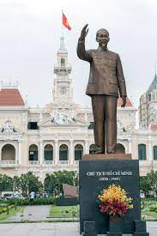 | 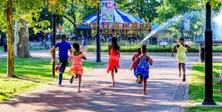 | 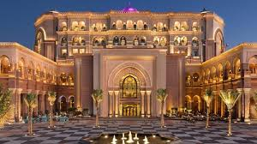
1. _______________ | 2. _______________ | 3. _______________
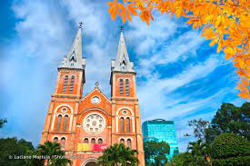 | 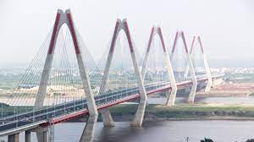 | 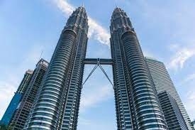
4. _______________ | 5. _______________ | 6. _______________
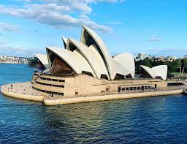 | 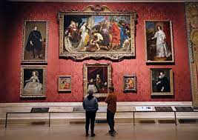
7. _______________ | 8. _______________
III. Choose the word or phrase (A, B, C or D) that best fits the space in each sentence.
- There’s a famous __________ called Reunification Palace in Ho Chi Minh City.
- park B. tower C. museum D. palace
- A _________ is a building in which objects of artistic, cultural, historical or scientific interest are kept and shown to the publish.
- statue B. bridge C. museum D. cathedral
- The _______ of Liberty is a gift from the people of France to the people of the United States.
- Palace B. Statue C. Park D. Building
- The Golden Gate _______ is in San Francisco, California, the United States.
- Church B. Bridge C. Tower D. Statue
- We will visit Hyde ________ this weekend if it doesn’t rain.
- Park B. Cathedral C. Opera House D. Museum
- Rapunzel was locked in a _________ for years in the movie Tangled.
- tower B. bridge C. statue D. palace
- They will visit St. Paul’s________ to pray this evening.
- Opera House B. Park C. Bridge D. Cathedral
- The Sydney ____________ is located on the banks of Sydney Harbour, Australia.
- Museum B. Tower C. Palace D. Opera House
- The Eiffel ________ in Paris is taller than the ______ of Liberty in New York.
- Tower/ Bridge B. Tower/ Statue C. Statue/ Tower D. Tower/ Cathedral
- Night at the ________ ,which is based on the 1993 children’s book, is a 2006 fantasy comedy film.
- Park B. Palace C. Museum D. Opera House

UNIT 10: CITIES AROUND THE WORLD

LESSON 1–2 (Grammar)

- Grammar: First conditional (Câu điều kiện loại 1)

Chức năng | Dùng để diễn tả một hành động có thể xảy ra ở hiện tại hoặc tương lai.
Cấu trúc | Đối với TO BE: If + S + am/ is/ are…, S + will + V  Đối với Verb: If + S + V(s/es) …, S + will + V….  (Thì Hiện tại đơn) , (Thì Tương lai đơn)
Ví dụ | - If I have enough money, I will buy a new computer.  (Nếu tôi có đủ tiền thì tôi sẽ mua một chiếc máy tính mới.)  - If you work hard, you will make a lot of money.  (Nếu bạn làm việc chăm chỉ thì bạn sẽ kiếm được nhiều tiền.)
Lưu ý | Unless = If + not Ví dụ:  - If he doesn’t do his homework, his mother will complain him.  => Unless he does his homework, his mother will complain him.  - If you don’t send her to the hospital, she will die.  => Unless you send her to the hospital, she will die.
Lưu ý | Có thể dùng các động từ must, have to, can, may, should thay cho will trong mệnh đề chính  Ví dụ:  - If it rains heavily, you can stay here.  (Nếu trời mưa to thì bạn có thể ở lại đây.)  - If you want to see that film, you must buy a ticket. (Nếu bạn muốn xem bộ phim đó thì bạn phải mua vé.)

II. Choose the word or phrase (A, B, C or D) that best fits the space in each sentence.
- If the weather (be) ___________ beautiful tomorrow, we (drive) ____________________ to the beach.
- If it (rain) _______________, we (not go) ______________________ fishing.
- If she (send) _________________ the letter now, we (receive) _____________________ it tomorrow.
- Fred (be) ___________________ angry if Jack (arrive) __________________ late again.
- I (come) ___________________ to your house if I (have) ________________ enough time.
- If I (not feel) _________________ better tomorrow, I (go) ________________ to the doctor’s.
- If they (win) _______________ this match, they (be) _________________ the champions.
- I (buy) ___________________ this machine if it (not cost) _____________________ too much.
- You (learn) _________________ a lot if you (take) _____________ the course.
- If you (catch) ________________ the taxi, you (run) ____________________ very fast.
III. Rearrange the sentences:
- do/ bad?/ will/ if/ What/ the weather’s/ you/
What ?
- I/ will visit/ time,/ If/ have/ the Central Park./ I/
If .
- famous / There’s/ palace / Ho Chi Minh City./ a/ in/
There’s .
- If/ I/ at home./ will/ bad,/ stay/ the weather’s/
If .
- go to/ is/ busy./ will/ the cathedral/ Mary/ if / the museum
Mary .

UNIT 10: CITIES AROUND THE WORLD

LESSON 1 – 3 (Pronunciation)

I. Find the word whose underlined part differs from the other three in pronunciation.
1. A. weather B. cathedral C. think D. thank
2. A. this B. think C. thank D. thing
3. A. fifth B. three C. birthday D. those
4. A. breathe B. teeth C. bath D. breath
5. A. then B. month C. third D. theater
II. Find the word that differs from the other three in the position of primary stress.
1. A. shopping B. building C. tower D. result
2. A. boring B. awful C. become D. funny
3. A. leadership B. animated C. comedy D. museum
4. A. exciting B. historical C. fantastic D. terrible
5. A. opera B. Vietnamese C. general D. president
III. Choose the word (A, B, C or D) that best fits the blank space in the following passage:
Tom: What are you going to do in Amsterdam?
Kathryn: First, I’m going to visit the Royal Palace.
Tom: It’s very busy (1) _______ weekends.
Kathryn: Really? Well, if it’s too busy, I’ll walk around Dam Square.
Tom: Good idea, the square (2) _______ beautiful. Are you going to the opera?
Kathryn: Yes, of course.
Tom: Do you have tickets? It’s very popular.
Kathryn: Oh no, I though it was free! What can I do if I can’t get tickets?
Tom: There’s a really nice park (3) ________ the opera house.
Kathryn: Great! If I can’t get tickets, I’ll take (4) _______ in the park.
Tom: What (5) ______ you do if the weather’s bad?
Kathryn: I’ll just stay in my hotel!
1. A. at B. on C. in D. for
2. A. be B. am C. is D. are
3. A. next B. near C. between D. front
4. A. walk B. walks C. photo D. photos
5. A. will B. are C. do D. does
IV. Rewrite each of the following sentences in another way so that it means almost the same as the
sentence printed before it.
- If I don’t go now, I will miss the train.
Unless .
- If he doesn’t work hard, he will not pass the exam.
Unless .
- Stop talking or you won’t understand the lesson.
If .
- Hurry up or you will be late for school.
If .
- Don’t make noise or you will wake the baby up.
If .

